Wampum Bracelet Project
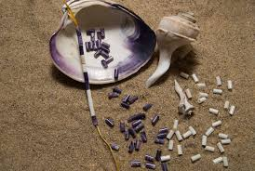
The Iroquois Native Americans were part of the Woodland culture and they lived in the Northeastern section which would be where New York is now. The Iroquois people made things out of white and purple shells that they used like beads. Some of the things that they made were belts, necklaces, bracelets and other decorative things. They called them wampum. Wampum was used like currency and was also used as a form of communication between Indian tribes. The Wampum belt’s designs even told the reason it was made. Wampum was a huge factor in the Iroquois tribes.
Making Our Own Wampum Bracelets
- Start by cutting about a yard of cord, folding it in half, and tying a knot in the folded end.
- Add a single bead on both strands of the cord
- Then add a bead on each side.
- Now add another single bead, on both strands, and tie a knot to secure.
- Repeat the process, adding two beads, then one, then a knot. Two beads, one, knot. over and over until your bracelet is the right length. Then fold the rest of the cording over to tie a BIG knot.
- Cut the excess cord, and tuck the knot into your loop from the beginning to close the bracelet.
http://30minutecrafts.com/2014/07/pony-bead-bracelet.html

